EXPERIMENT 2

Implementation of Greedy Agent

Code

import numpy as np

import matplotlib.pyplot as plt

n_arms = 3

true_rewards = [0.35, 0.70, 0.105]

n_steps = 100

reward_sums = np.zeros(n_arms)

counts = np.zeros(n_arms)

estimated_rewards = np.zeros(n_arms)

reward_history = []

cumulative_reward = []

for arm in range(n_arms):

reward = int(np.random.rand() < true_rewards[arm])

reward_sums[arm] += reward

counts[arm] += 1

estimated_rewards[arm] = reward_sums[arm] / counts[arm]

reward_history.append(reward)

cumulative_reward.append(sum(reward_history))

for step in range(n_arms, n_steps):

arm = np.argmax(estimated_rewards)

reward = int(np.random.rand() < true_rewards[arm])

reward_sums[arm] += reward

counts[arm] += 1

estimated_rewards[arm] = reward_sums[arm] / counts[arm]

reward_history.append(reward)

cumulative_reward.append(cumulative_reward[-1] + reward)

print("\n=== Final Results ===")

print("True Reward Probabilities: ", true_rewards)

print("Estimated Reward Probabilities: ", np.round(estimated_rewards, 2))

print("Number of times each arm was selected:", counts)

print("Total Reward Earned: ", int(sum(reward_history)))

plt.figure(figsize=(10, 5))

plt.plot(cumulative_reward, label="Cumulative Reward", color='blue')

plt.xlabel("Steps")

plt.ylabel("Total Reward")

plt.title("Greedy Agent - Reward Over Time")

plt.grid(True)

plt.legend()

plt.tight_layout()

plt.show()

Output

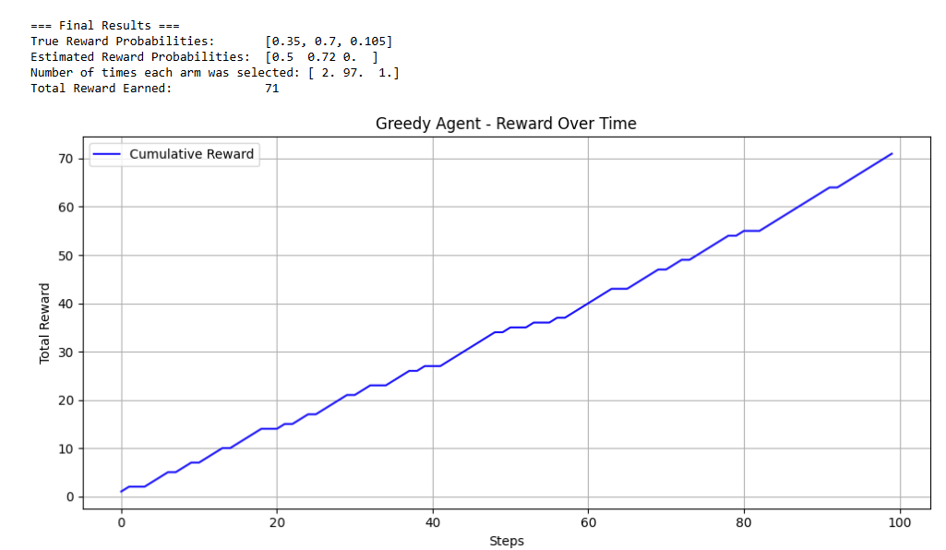

**MUGESH K**

**E0123038**